Steven Houser
Slide and Catch Game - Part II - Game Design Document
11/07/25
Goal: Create a complete "slide and catch" game where a cauldron at the bottom of the screen catches falling candy. The player controls the cauldron's horizontal movement using arrow keys, and scores points by catching candy pieces as they fall from random positions at the top. There are two types of candy: regular candy worth 1 point and bonus candy worth 2 points. The game features a time limit with countdown timer, score tracking, an instruction screen, and sound effects.
Game Design Diagrams:
Phase State Diagram
This game will have a very basic two-state system. Each state will be represented by a subclass of the simpleGE Scene class. The player is initially sent to the Intro scene. This will display instructions and two buttons. The buttons both close the scene, but before closing the scene, they will set a response variable indicating the user's preference. If the user chooses to play the game, they are sent to the game play scene. If they choose to quit, the game ends.
The game play scene always ends when the time expires and always returns control to the intro scene. However, it does pass back its score to the main function, which uses that score to provide feedback to the user in the intro scene.
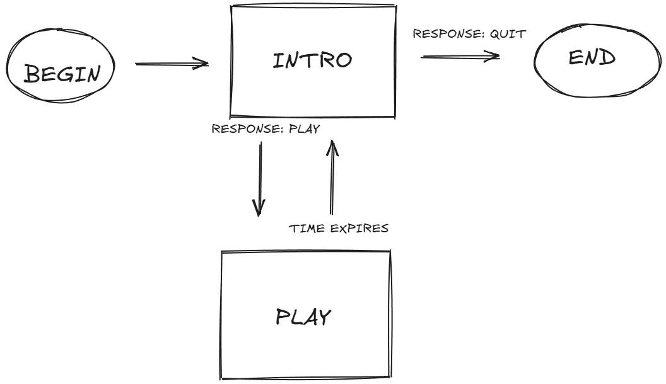
Game Design Diagram - Instructions Screen
This scene has four main visual elements:
• instructions - a stock simpleGE MultiLabel containing instructions for game play
• lblScore - a stock label showing the previous score
• btnPlay - a stock button indicating "Play"
• btnQuit - a stock button indicating "Quit"
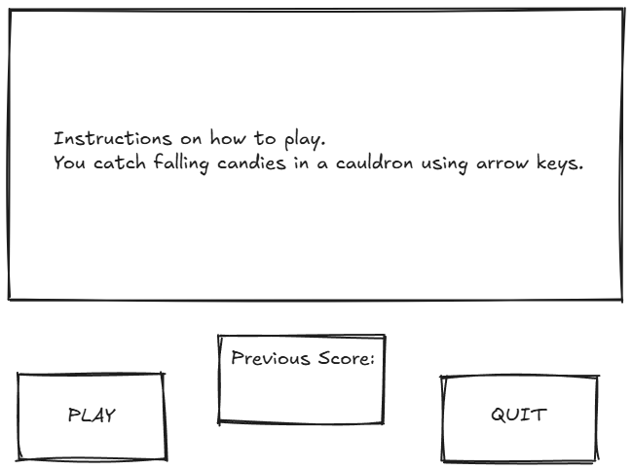
Game Design Diagram - Game Screen
The Game class will have a number of visual attributes:
• cauldron - an instance of the Cauldron class (see below)
• candies - a list containing 15 total falling objects: 10 Candy instances (1 point each) and 5 Candy2 instances (2 points each)
• lblScore - an instance of the LblScore class (see below)
• lblTime - an instance of the LblTime class (see below)
It will also contain some non-sprite assets:
• timer - a stock instance of the simpleGE.Timer class
• score - an int containing the current score
• sndCatch - a stock instance of the simpleGE.Sound class
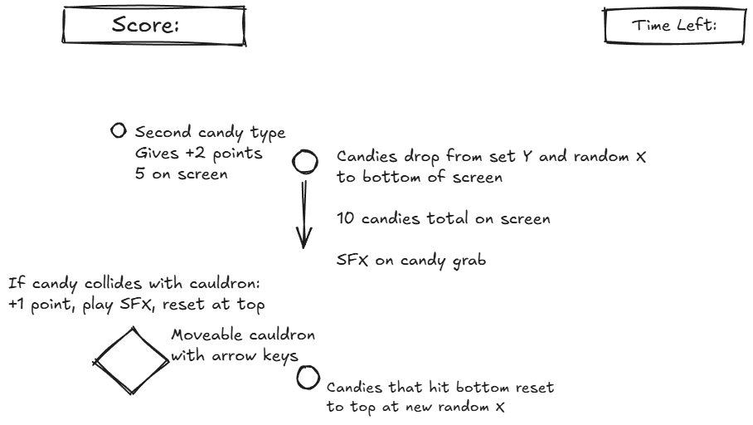
Scene and Class Descriptions:
Instructions Scene (Instructions class)
Variables needed:
• response (string for user's choice - "Play" or "Quit")
• prevScore (integer for previous game's score)
• instructions (MultiLabel widget for game instructions)
• lblScore (Label widget showing last score)
• btnPlay (Button widget for starting game)
• btnQuit (Button widget for exiting)
• sprites (list of all visual elements in the scene)
init(score):
1. Initialize the scene
2. Set background image with try/except error handling
- If error occurs, print error message and use fallback color
3. Set response = "Play" (default value)
4. Set prevScore = score (from parameter)
5. Create instructions MultiLabel widget
6. Set instruction text lines
7. Position instructions at center (320, 240)
8. Set instruction size (600, 250)
9. Set instruction background color to black (0, 0, 0)
10. Set instruction foreground color to white (255, 255, 255)
11. Create score label widget
12. Set score label text to show previous score
13. Position score label at (320, 400)
14. Set score label size to (300, 30)
15. Set score label background color to black (0, 0, 0)
16. Set score label foreground color to white (255, 255, 255)
17. Set score label clearBack to False (solid background)
18. Create Play button widget
19. Set Play button text to "Play"
20. Position Play button at (100, 400)
21. Create Quit button widget
22. Set Quit button text to "Quit"
23. Position Quit button at (550, 400)
24. Create sprites list with all widgets
process():
1. Check if Quit button was clicked
- If True: Set response = "Quit" and stop the scene
2. Check if Play button was clicked
- If True: Set response = "Play" and stop the scene
Game Scene (Game class)
Variables needed:
• timer (Timer object for tracking game time - set to 10 seconds)
• score (integer for current player score, starts at 0)
• sndCatch (Sound effect object for candy catch sound)
• cauldron (Cauldron sprite object)
• numCandies (integer constant for number of regular candies, set to 10)
• numCandies2 (integer constant for number of bonus candies, set to 5)
• candies (list of Candy and Candy2 sprite objects - 15 total)
• lblScore (Label widget for displaying score)
• lblTime (Label widget for displaying time remaining)
• sprites (list of all sprites and GUI elements)
init():
1. Initialize the scene
2. Set background image with try/except error handling
- If error occurs, print error message and use fallback color
3. Create timer object
4. Set timer to 10 seconds
5. Set score = 0
6. Create sound effect object with try/except error handling
- If error occurs, print warning message and continue without sound
7. Create cauldron sprite
8. Set number of regular candies = 10
9. Create empty candies list
10. Use for loop to create 10 Candy sprites (1 point each) and add to candies list
11. Set number of bonus candies = 5
12. Use for loop to create 5 Candy2 sprites (2 points each) and add to candies list
13. Create score label
14. Create time label
15. Create sprites list with cauldron, candies, score label, and time label
process():
1. Loop through each candy in candies list:
- Check if cauldron collides with candy
- If True:
- Play sound effect
- Reset candy position
- Increase score by candy's points value (1 or 2)
- Update score label text
2. Update time label to show remaining time
3. Check if timer has expired (time remaining less than 0)
- If True: Print final score message and stop the scene
Cauldron Sprite (Cauldron class)
Variables needed:
• moveSpeed (integer for pixels to move per frame, set to 5)
• x, y (position coordinates on screen)
• position (starting position tuple - 320, 400)
• image (sprite image)
• rect (collision rectangle)
init(scene):
1. Initialize the sprite
2. Load cauldron image with try/except error handling
- If error occurs, print error message and use placeholder
3. Set sprite size to 50x50 pixels
4. Set starting position to (320, 400)
5. Set moveSpeed = 5
process():
1. Check if LEFT arrow key is pressed
- If True: Move cauldron left by moveSpeed pixels
2. Check if RIGHT arrow key is pressed
- If True: Move cauldron right by moveSpeed pixels
Candy Sprite (Candy class)
Variables needed:
• x, y (position coordinates)
• dx, dy (movement speed components)
• points (integer value - set to 1)
• image (sprite image)
• rect (collision rectangle)
• screenWidth, screenHeight (screen dimensions)
init(scene):
1. Initialize the sprite
2. Load candy image with try/except error handling
- If error occurs, print error message and use placeholder
3. Set sprite size to 25x30 pixels
4. Set points value to 1
5. Call reset() to set starting position and speed
reset():
1. Set starting y position to top of screen (y = 10)
2. Set random x position across screen width
3. Set random downward speed (between 3 and 8 pixels per frame)
4. Set horizontal speed to 0 (moves straight down)
checkBounds():
1. Check if candy has fallen off bottom of screen
- If True: Call reset() to move candy back to top with new random position and speed
Candy2 Sprite (Candy2 class)
Variables needed:
• x, y (position coordinates)
• dx, dy (movement speed components)
• points (integer value - set to 2)
• image (sprite image)
• rect (collision rectangle)
• screenWidth, screenHeight (screen dimensions)
init(scene):
1. Initialize the sprite
2. Load candy2 image with try/except error handling
- If error occurs, print error message and use placeholder (orange color)
3. Set sprite size to 25x30 pixels
4. Set points value to 2
5. Call reset() to set starting position and speed
reset():
1. Set starting y position to top of screen (y = 10)
2. Set random x position across screen width
3. Set random downward speed (between 3 and 8 pixels per frame)
4. Set horizontal speed to 0 (moves straight down)
checkBounds():
1. Check if candy has fallen off bottom of screen
- If True: Call reset() to move candy back to top with new random position and speed
Score Label (LblScore class)
Variables needed:
• text (string for display text, initially "Score: 0")
• center (position tuple - 100, 30)
• bgColor (background color tuple - black (0, 0, 0))
• fgColor (foreground color tuple - white (255, 255, 255))
• clearBack (boolean - True for transparent background)
init():
1. Initialize the label
2. Set text = "Score: 0"
3. Set center position to (100, 30)
4. Set background color to black (0, 0, 0)
5. Set foreground color to white (255, 255, 255)
6. Set clearBack = True (transparent background)
Time Label (LblTime class)
Variables needed:
• text (string for display text)
• center (position tuple)
• bgColor (background color tuple)
• fgColor (foreground color tuple)
• clearBack (boolean - True for transparent background)
init():
1. Initialize the label
2. Set text = "Time Left: 10"
3. Set center position to (500, 30)
4. Set background color to black (0, 0, 0)
5. Set foreground color to white (255, 255, 255)
6. Set clearBack = True (transparent background)
Main Function
Variables needed:
• keepGoing (boolean for loop control)
• score (integer for current game score)
• instructions (Instructions scene object)
• game (Game scene object)
main():
1. Import pygame, random, and simpleGE modules
2. Set keepGoing = True
3. Set score = 0
4. While keepGoing is True:
- Create Instructions scene with current score
- Start Instructions scene
- Check scene response:
- If response is "Play":
- Create Game scene
- Start Game scene
- Update score from game
- If response is "Quit":
- Set keepGoing = False
5. Program ends when loop exits
Assets
Background Image:
• File: background.png
• Used for both Instructions and Game scenes
• Source: https://craftpix.net/freebies/free-halloween-2d-game-backgrounds/?num=1&count=10&sq=halloween&pos=4
Cauldron Sprite:
• File: cauldron.png
• Source: https://katy-elizabeth.itch.io/halloween-props-pack-2
Candy Sprite (1 point):
• File: candy1.png
• Source: https://katy-elizabeth.itch.io/halloween-props-pack-2
Candy2 Sprite (2 points):
• File: candy2.png
• Source: https://katy-elizabeth.itch.io/halloween-props-pack-2
Sound Effect:
• File: catch.wav
• Plays when candy is caught
• Source: https://freesound.org/people/Mihacappy/sounds/828150/

